Second Semester
CSE
CS3401 - Model Examination
(Regulation 2023)
Time: Three Hours | Maximum Marks: 100 Marks
 | PART- A | (10 x 2 = 20 Marks)
Q.No. | Answer ALL Questions | CO | BTL | Marks
1 | Poisson's ratio for aluminium is? Justify your answer? a)0.13 b) 0.23 c)0.33 d)0.43 | CO1 | 3 | 2
2 | Summarize about Principles of Superposition. | CO1 | 2 | 2
3 | False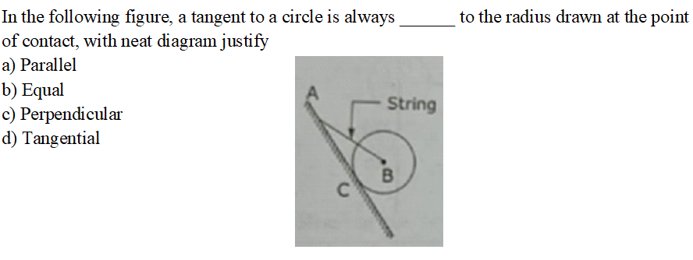 | CO2 | 2 | 2
4 | Define resolution of a force | CO2 | 1 | 2
5 | Select and justify, for a projectile, the maximum horizontal range Rmax occurs when the angle of projection (θ) is  a) 0∘  b) 60∘  c) 90∘  d) 45∘ | CO3 | 4 | 2
6 | Compare angle of projection and velocity of projectile. | CO3 | 4 | 2
7 | What does a negative value for a member force calculated using the Method of Joints typically indicate, if the force was initially assumed to be in tension (pulling away from the joint)? a) The member is a Zero-Force Member. b) The magnitude calculation is incorrect. c) The structure is unstable. d) The member is in Compression. | CO4 | 4 | 2
8 | Discover the assumptions made in the analysis of truss to estimate the member property. | CO4 | 4 | 2
9 | Power transmitted by a shaft is given by. Justify your answer.  a) P = 2πNT/60  b) P = T/2πN  c) P = TN/60  d) P = 2πT/N | CO5 | 4 | 2
10 | Derive the torsion equation of a shaft in pump and explain each term. | CO5 | 4 | 2
 | PART- B | (5 x 16 = 80 Marks)
Q.No. | Answer All Questions | CO | BTL | Marks
11 a | A mild steel rod of 20 mm diameter and 300 mm long is enclosed centrally inside a hollow copper tube of external diameter 30 mm and internal diameter of 25 mm. The ends of the tube and rods are brazed together, and the composite bar is subjected to an axial pull of 40 kN. If E for steel and copper is 200 GN/m² and 100 GN/m² respectively, find the stresses developed in the rod and tube. Also find the extension of the rod. | CO1 | 3 | 16
(OR)
11 b | Derive expressions for Young’s modulus, Bulk modulus, and Shear modulus from first principles, stating all necessary assumptions. Explain how these moduli are interrelated | CO1 | 3 | 16
12 a | Extrapolation from a concept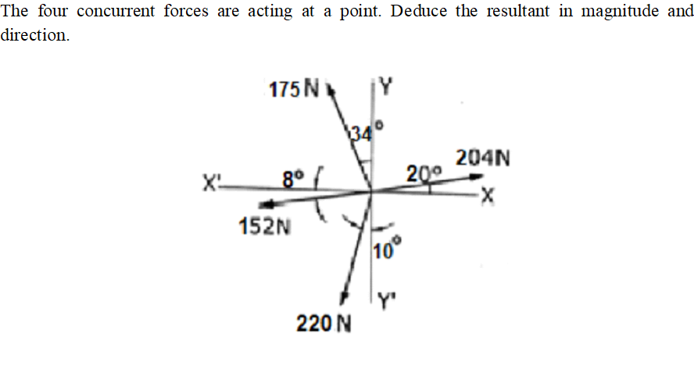 | CO2 | 2 | 16
(OR)
12 b | Estimation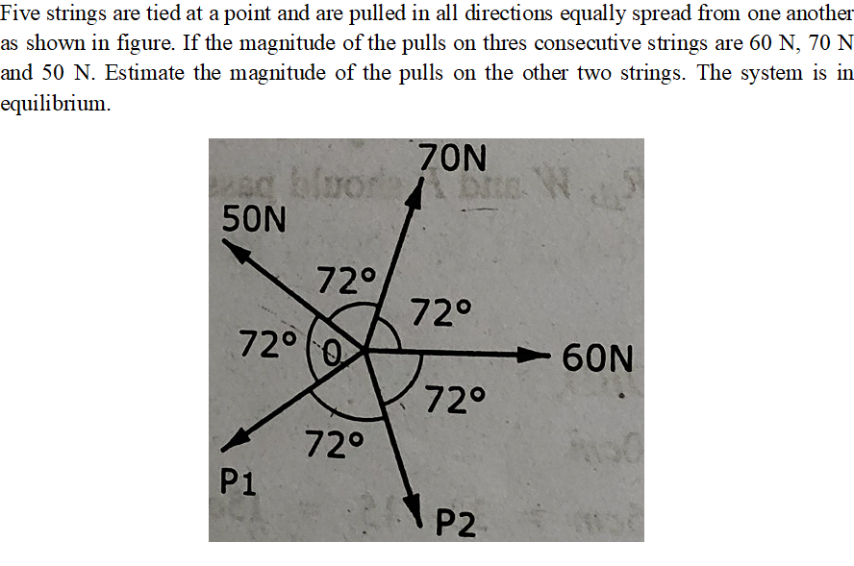 | CO2 | 2 | 16
13 a | Two trains A and B leave the same station on parallel lines. Train A starts with an uniform acceleration of 0.5 m/s² and attains a speed of 36 km/hour, when steam is reduced to keep the speed constant. Train B leaves 30 seconds after, with uniform acceleration of 1 m/s² to attain a maximum speed of 54 km/hour. Identify the time, the train A when will overtake to A? | CO3 | 3 | 16
(OR)
13 b | A particle is projected with an initial velocity of 10 m/s at an angle α with the horizontal. After some time, the position of the particle is observed by its x and y distances of 12 m and 8 m respectively from the point of projection. Identify the angle of projection. | CO3 | 3 | 16
14 a | Calculation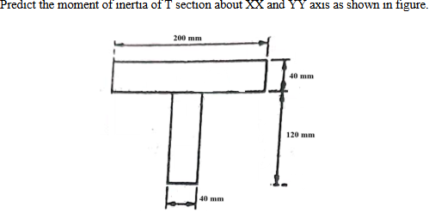 | CO4 | 3 | 16
(OR)
14 b | Modification of existing designs and justify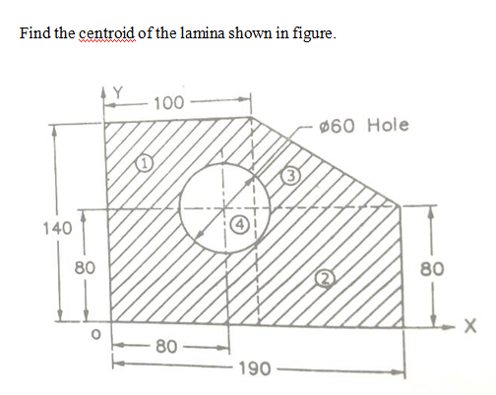 | CO4 | 3 | 16
15 a | A cantilever of length 5m carries a uniformly distributed load of 2kN/m length over the whole length and a point load of 4kN at the free end. Draw the SFD and BMD for the cantilever. | CO5 | 3 | 16
(OR)
15 b | Determine the diameter of a solid shaft which will transmit 90 kW at 160 r. p. m. Also determine the length of the shaft if the twist must not exceed 1º over the entire length of the shaft. The maximum shear stress is limited to 60 N/mm². Take the vales of modulus of rigidity 8x10⁴ N/mm². | CO5 | 3 | 16

******************
QP123

